Exhibition of Historical Data, old ticket and Art-(Pottery) Date: 25 January 2019.
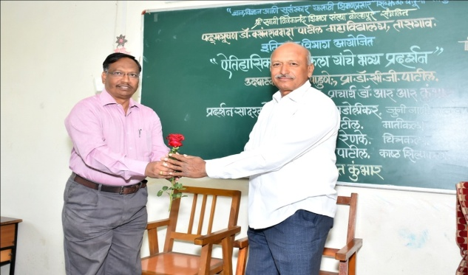 | 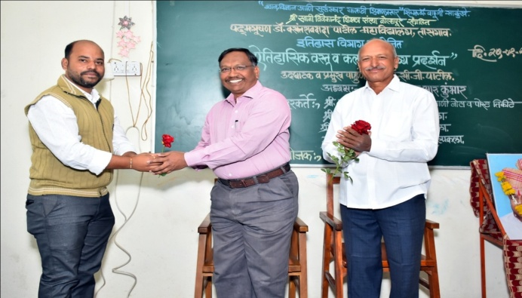
Welcome to Chief Guest Prof. Dr. C.G. Patil, Tasgaon | Welcome to Chairperson Principal. Dr. R. R. Kumbhar
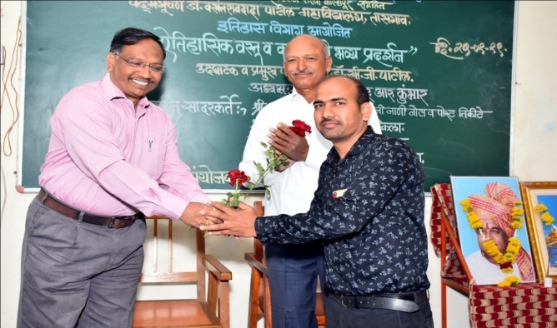 | 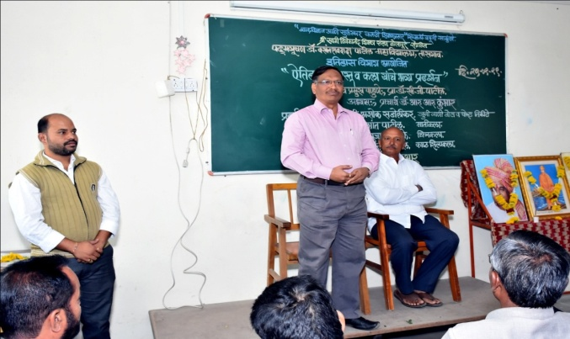
Welcome to Organizer HOD. Dr. Haji Nadaf | Chairman Speech Principa Dr R. R. Kumbhar
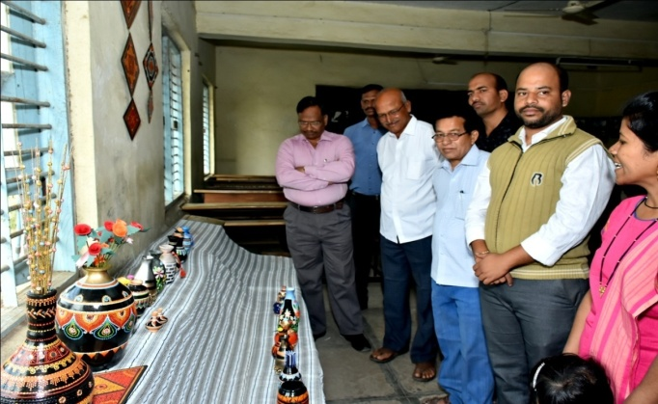 | 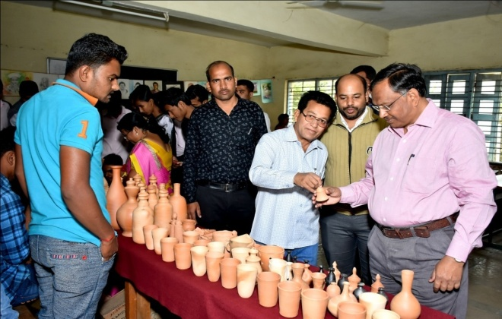
Art – Pottery Exhibition
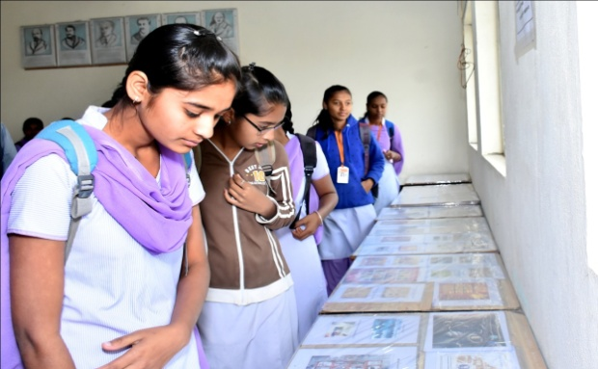 | 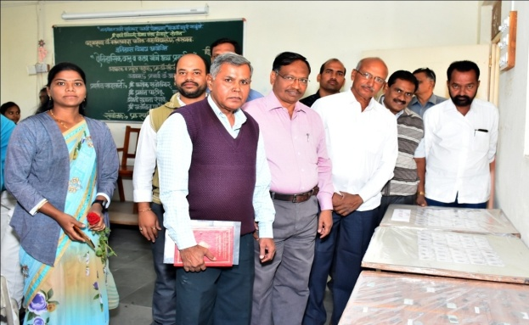
Historical old Document Exhibition | Historical old Postal Ticket Exhibition

